- Name the tissue
- Which classification of CT?
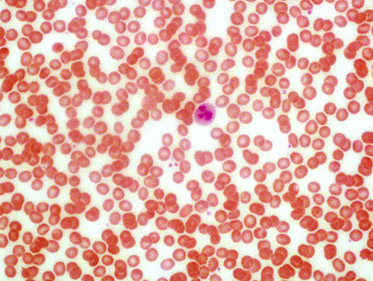

- Name the tissue
- Where would I find it?
- What is the name of the cells?
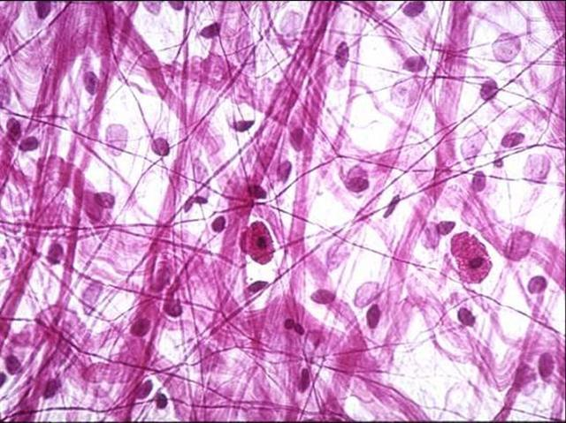

- Name the tissue
- Where would I find this?
- What is the name of the cells?
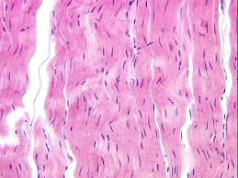

- Name the tissue
- Where would I find this?
- What is the name of the cells?
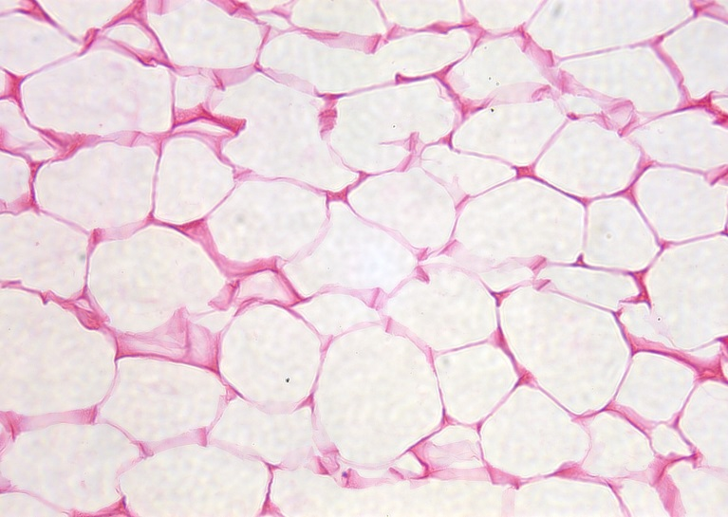

- Name the tissue
- Where would I find this?
- What is the name of the cells?
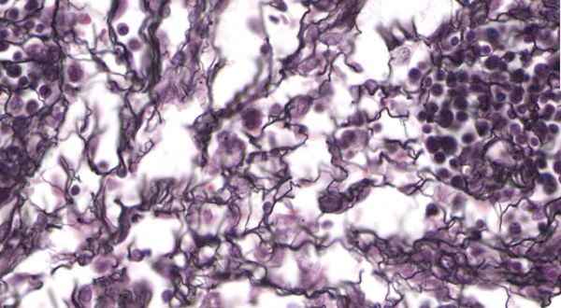

- Name the tissue
- Where would I find this?
- What is the name of the cells?

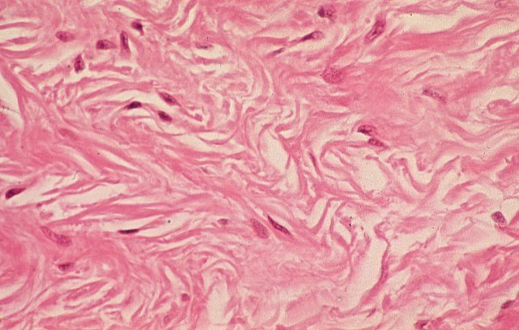

- Name
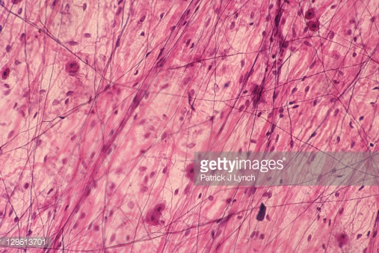
- Name
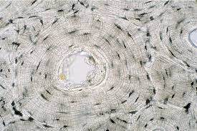

20.Name 2 cell types ( one CT and one Epithelial)
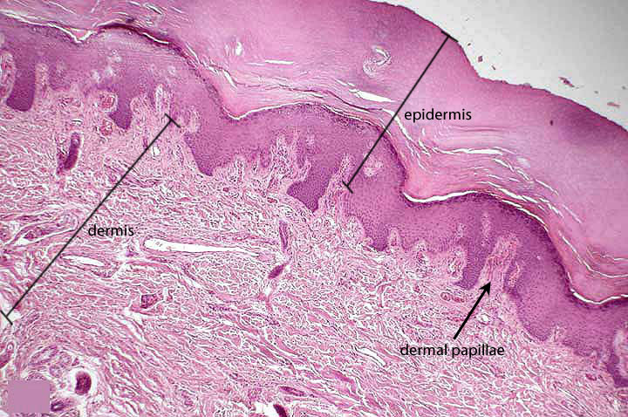

21.. What is layer D

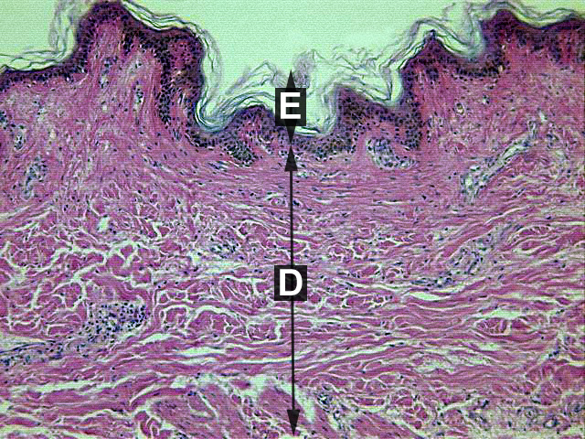
22. 