Try your best ☺

1. What types of tissue below?
2. Where would you most likely find it?

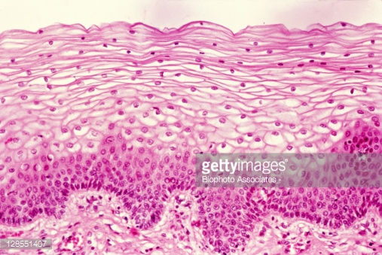

1. What type of tissue below?
2. Where would you find it? 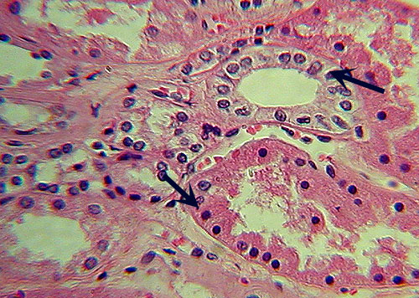
3. What type of tissue?
4. Where would you find it?

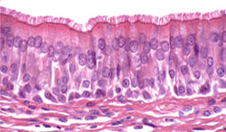

1. What type of tissue ?
2. Where would you find it?

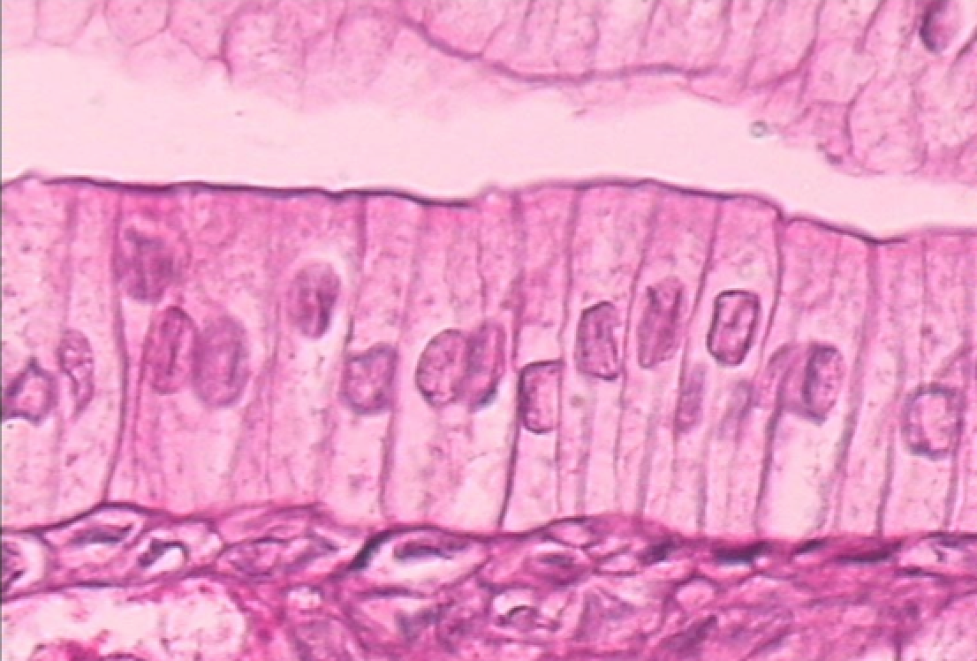

1. What type of tissue?
2. Where would you find it?

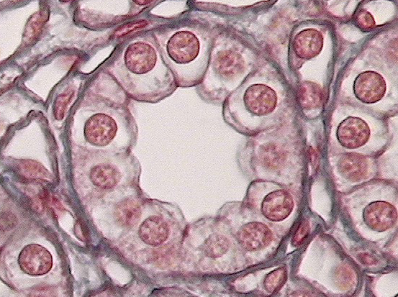

1. What type of tissue?

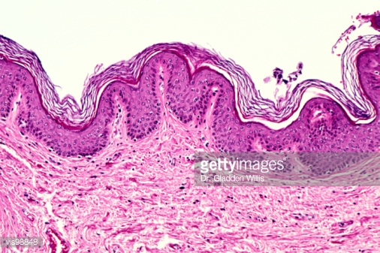

1. 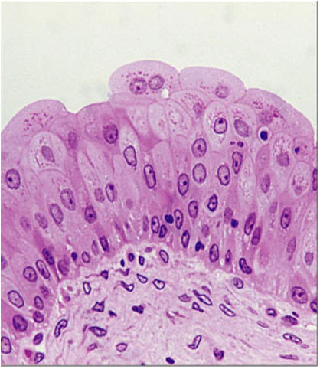What type of tissue
2. Where would you find it?
3. What type?

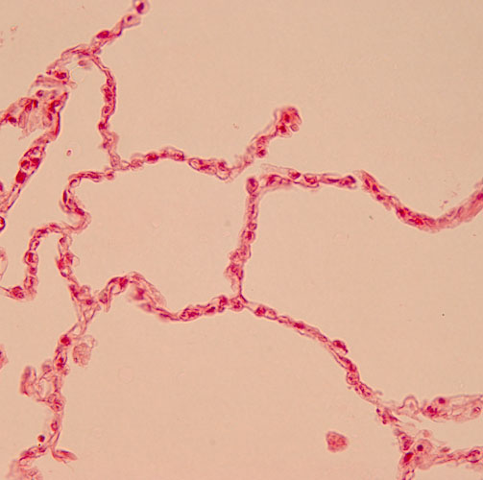

1. What type?

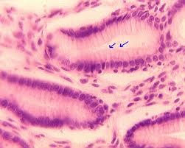

1. What type?

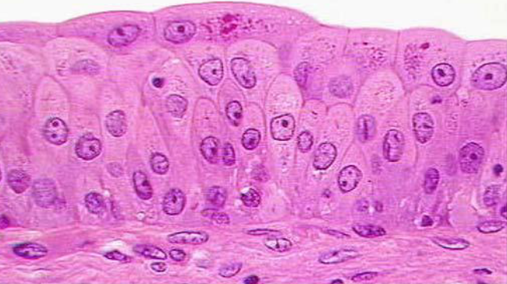

1. What type?

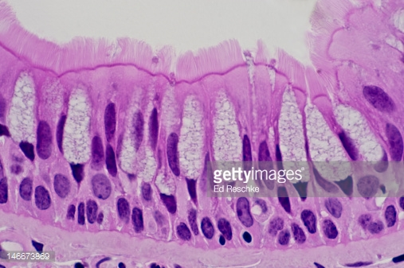

1. What layer are the arrows pointing to?

