Anatomy of the Heart
Instructions: Color and Label the following: Right atrium, Left atrium, Right ventricle, Left ventricle, Tricuspid Valve, Mitral valve, Pulmonary Valve, Superior vena cava, inferior vena cava, Aorta, left pulmonary artery, right pulmonary artery, left pulmonary veins.

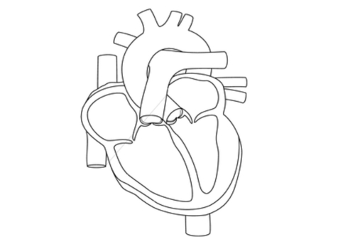

Blood Flow through the Heart

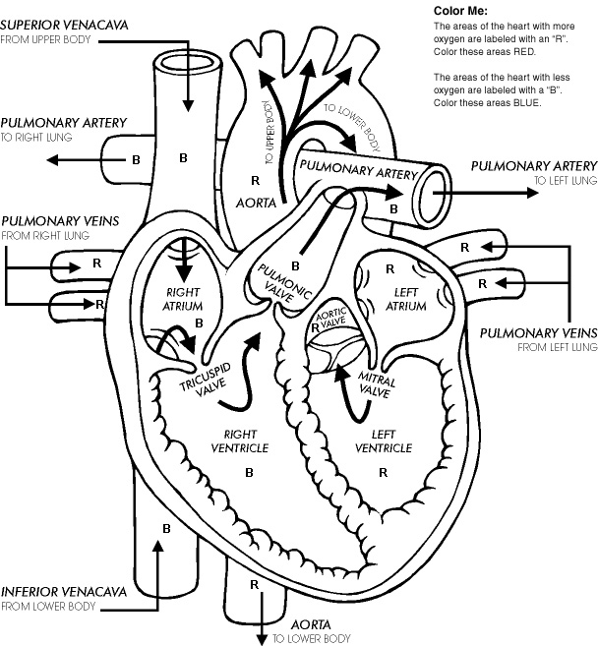

Major Arteries of the Body

Renal Artery, Subclavian Artery, Coronary Arteries, Digital Arteries, Radial artery, Ulnar Artery, Brachial artery, Femoral Artery, Common carotid artery, external carotid artery, aortic arch, Common Iliac artery, external iliac, internal iliac,

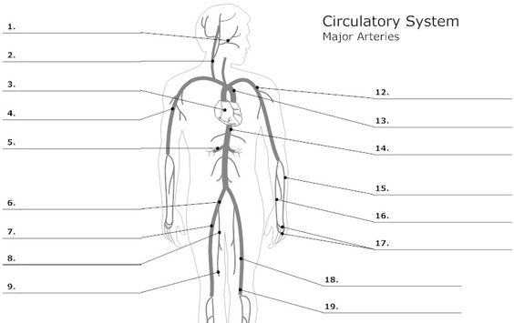

Anatomy of the Upper Respiratory Tract

Color and Label the following regions.
Nasopharynx
Pharyngeal tonsil
Oropharynx
Laryngopharynx
Trachea
Esophagus
Vocal Folds
Epiglottis
Larynx

Unit 6 Portfolio

- Components of blood- Create a chart that describes the characteristics and roles of the various components of blood. Include drawings of each of the blood cells. (4 points)

- Types of Blood Vessels- List and Describe the function of the different type of arteries and veins (3 points)

- Complete the “Anatomy of the heart” diagram. Color it and label it with the words at the top of the page. (3 points)

- Blood Flow of the Heart - Color the blood flow of the heart worksheet. (1 point)

- Draw the negative feedback loop involving the baroreceptor reflex (706) and the regulation of normal blood pressure.

- Anatomy of the Upper Respiratory Tract Worksheet (3 points)

- Sequence of events during inspiration and expiration- Describe the flow of events during inspiration and expiration of the lungs. (2 points)

- HONORS ONLY- Summarize the article “atherosclerosis? Get out the Cardiovascular Drano” article on pages 700-701.

